BattleField 5



Release:15th Nov 2018

Score: 85/100

Platform: PS4, Xbox one, PC

Link: https://uk.ign.com/games/battlefield-5

Description:

Chaos and scale have always been the foundation of the Battlefield franchise, and Battlefield V is no different. Squads of soldiers relentlessly push towards objectives with either sheer force or improvised tactics while gunfire and explosions ring throughout the beautiful, but war-torn landscapes. It's an overwhelming sensory experience and a fine execution of a familiar formula--if you play the better modes.

Battlefield V goes back to where the franchise began by using World War II's European theater as the backdrop for first-person shooting and vehicular combat in large multiplayer matches. It's not too dissimilar to Battlefield 1, where every weapon has a distinct weight and impact that comes through vividly in both sight and sound. The core conceits of Battlefield remain mostly untouched, but small tweaks have been made to the formula, most of which are welcome.

DIVINITY: ORIGINAL SIN II

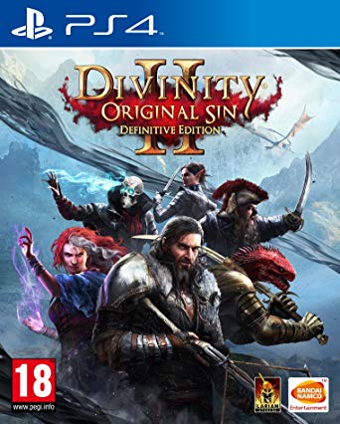

Release: Aug 31, 2018

Platform: PC, PS4/, Xbox One

Rating: 95/100

Link: <https://www.metacritic.com/game/pc/divinity-original-sin-ii---definitive-edition>

Summery:

Divinity: Original Sin II is an epic RPG with turn-based combat and cooperative/competitive multiplayer. The game's devotion to the greatest elements of RPG mechanics include party-based role-playing game (with pen & paper RPG-like levels of freedom,) a strong focus on systematic gameplay and a well-grounded narrative. Generations after the events of Divinity: Original Sin, the upstart Bishop Alexandar the Innocent has declared Source the sole preserve of the Divine Order. Sourcerers are now criminals, and those suspected of having Source powers are hunted, apprehended, and forcibly purged of their powers -- leaving only empty bodies, devoid of emotion or free will, behind. Four burgeoning Sourcerers from around the realm are each a victim of Alexandar’s pogrom. There’s a bounty on your head. Divine Order magisters are hunting you. You don’t know who to trust, and the world is anything but your friend. To save yourself, you'll need to take on the greatest Sourcerer the world has ever known. You'll have to negotiate betrayal and deceit, the politics of a world tearing itself apart, and deal with your own Source powers. Travelling through majestic cities, dangerous wastelands, lost temples, and war-torn battlefields, you will be looking for a way to defeat Alexandar, discovering that the only way lies deep within yourself. It will be, without a doubt, the journey of a lifetime.

UNDERTALE



Release date: Sep 18, 2018

Platform : PC, PS4, PS Vita

Rating: 93/100

Link: <https://www.metacritic.com/game/switch/undertale>

Summary: Welcome to UNDERTALE. In this RPG, you control a human who falls underground into the world of monsters. Now you must find your way out... or stay trapped forever. ((Healthy Dog's Warning: Game contains imagery that may be harmful to players with photosensitive epilepsy or similar condition.)) features: * Killing is unnecessary: negotiate out of danger using the unique battle system. * Time your attacks for extra damage, then dodge enemy attacks in a style reminiscent of top-down shooters. * Original art and soundtrack brimming with personality. * Soulful, character-rich story with an emphasis on humor. * Created mostly by one person. * Become friends with all of the bosses! * At least 5 dogs. * You can date a skeleton. * Hmmm... now there are 6 dogs...? * Maybe you won't want to date the skeleton. * I thought I found a 7th dog, but it was actually just the 3rd dog. * If you play this game, can you count the dogs for me...? I'm not good at it.

FORZA HORIZON 4

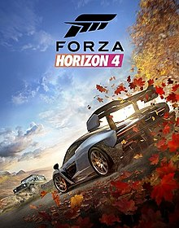

Release: Sep 28, 2018

Platforms : Xbox One, PC

Rating: 92/100

Link: https://www.metacritic.com/game/xbox-one/forza-horizon-4

Summary: Accelerate through historic Britain as you become a Horizon Superstar collecting 450 cars from 100 licensed manufacturers in Forza Horizon 4. For the first time in the series, you can experience dynamic seasons in this shared open-world.

Discover lakes, castles and the breath-taking scenery in incredible 4K and HDR. The world evolves and changes as the seasons do so you must master driving in dry, wet, muddy, snowy and icy conditions.

Get in gear as you explore this open-ended campaign where you can go alone or join multiplayer for a wild race. Forza Horizon 4 has more fun and rewarding gameplay than ever before.

**HITMAN 2 REVIEW**

HITMAN 2

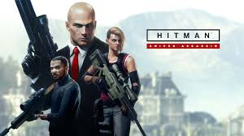

Release date: Nov 9, 2018

Rating: 84/100

Platforms: Xbox One, PS4, PC

Link: https://www.metacritic.com/game/xbox-one/hitman-2

Summary:

Travel the globe and track your targets across exotic sandbox locations in Hitman 2. From sun-drenched streets to dark and dangerous rainforests, nowhere is safe from the world's most deadly assassin, Agent 47. Prepare to experience the ultimate spy thriller story -- your mission is to eliminate the elusive Shadow Client and unravel his militia, but upon learning your target's true identity and the truth about 47's past, nothing will ever be the same.

Call of Duty: Black Ops 4

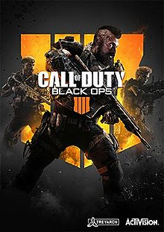

Release: Oct 12, 2018

Platform: PC, PS4, Xbox One

Rating: 88/100

Link: <https://www.metacritic.com/game/xbox-one/call-of-duty-black-ops-4>

Summary: Black Ops returns - in your face. Featuring gritty, grounded, fluid Multiplayer combat, a massive Zombies offering with 3 full undead adventures at launch, and Blackout, where the universe of Black Ops comes to life in one huge battle royale experience featuring the largest map in Call of Duty history, signature Black Ops combat, characters, locations and weapons from the entire Black Ops series. Soldier up for all-out combat – tailor made for the Black Ops community.

ASSASSIN'S CREED ODYSSEY

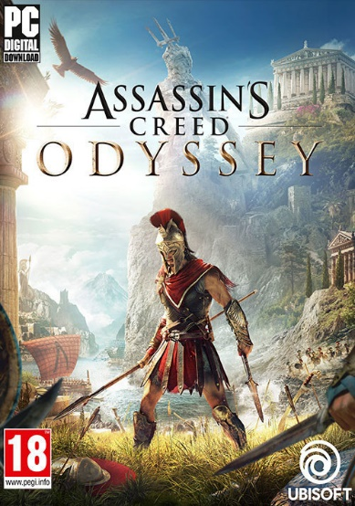

Release date: Oct 2, 2018

Rating:87/100

Platform: Xbox One, PC, PS4

Link: https://www.metacritic.com/game/xbox-one/assassins-creed-odyssey

Summary: Write your own epic odyssey and become a legendary Spartan hero. Forge your destiny in a world on the brink of tearing itself apart. Influence how history unfolds in an ever-changing world shaped by your choices.

Features:

* LEGENDARY SPARTAN HERO - Embark on your journey from outcast to legendary Spartan hero.

* ANCIENT GREECE AWAITS - Explore an entire country full of unexpected encounters in untamed environments and bustling ancient cities.

* CHOOSE YOUR PATH - Your choices shape the world around you. Play in a living world that constantly reacts to your every decision.

* FIGHT EPIC BATTLES - Charge into epic clashes between Sparta and Athens in battles pitting 150v150 soldiers against each other.

* SAIL THE AEGEAN SEA - Recruit crewmembers and customize your ship as you explore and battle your way on the open seas.

DESTINY 2: FORSAKEN

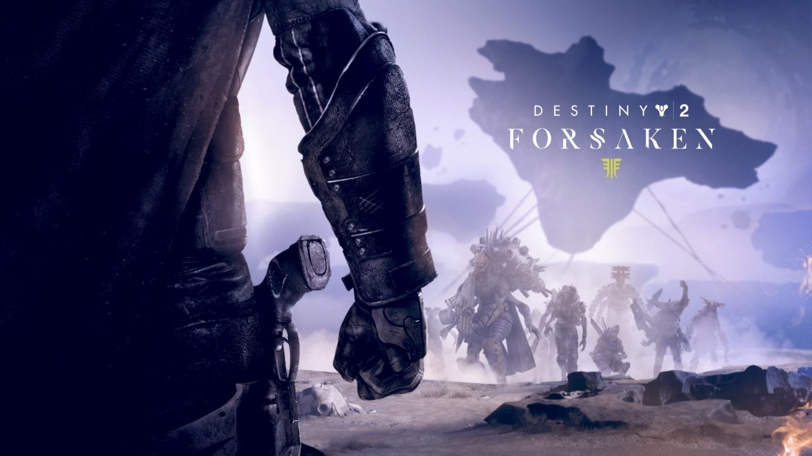

Release date: Sep 4, 2018

Rating: 86/100

Platform: Xbox One, PC, PS4

Link: https://www.metacritic.com/game/xbox-one/destiny-2-forsaken

Summary: With 2 brand-new destinations to explore, and new weapons, armour and Supers to acquire, Forsaken takes players on an epic journey into the wild frontiers of our solar system where the lines between justice and revenge are blurred. Forsaken also features an all-new competitive and collaborative endgame activity, called Gambit. A first-of-its kind for Destiny, Gambit is a new, hybrid 4v4 mode that merges both PvE and PvP experiences into an epic battle. This entirely new way to play Destiny 2 offers something for all types of gamers to enjoy, appealing to those who thrive on the competitive challenge of PvP gameplay, while seamlessly blending the collaborative and unpredictable elements of PvE.

NBA 2K19

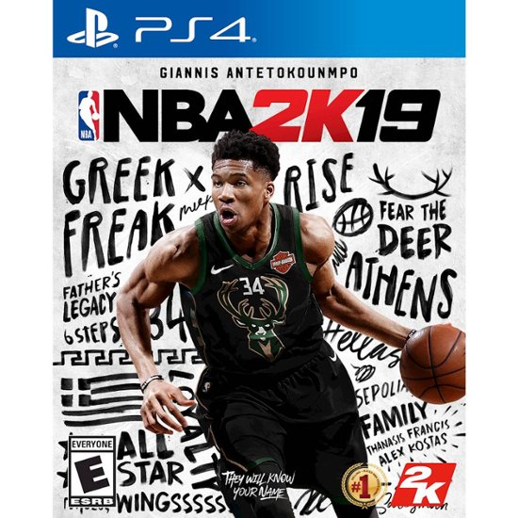

Release date: Sep 7, 2018

Rating: 83/100

Platform: Xbox One, PC, PS4, Switch

Link: <https://www.metacritic.com/game/xbox-one/nba-2k19>

Summary: NBA 2K celebrates 20 years of redefining what sports gaming can be, from best in class graphics & gameplay to groundbreaking game modes and an immersive open-world "Neighborhood." NBA 2K19 promises to push limits as it brings gaming one step closer to real-life basketball excitement and culture.